**Lesson 1 of 3: Every Home Needs CO Alarms**



Project Airy the Canary

[*www.airythecanary.com*](www.airythecanary.com%20)

Grades K-2

Carbon monoxide (CO) ∙ Canaries ∙ Alarms

* **Have you ever heard of Carbon Monoxide (CO)?**
* **Meet Airy - Canaries as alarms**
* **Do you have Carbon Monoxide Alarms at home?**

__________________________________________________________________________________________________

1. **Carbon monoxide is poisonous/toxic/bad air that can hurt us (and our pets) if we breathe it.** It’s invisible! We can’t smell it. We can’t taste it. It’s especially dangerous if we breathe it while we are asleep because it won’t wake us up before it starts hurting us. We need a way to detect it if it’s in the air…but how? How could you know if you were breathing poisonous air that you could not see or smell?
   * Encourage discussion about the concept of an undetectable “silent” gas (What would it look like? How would we draw it?)
2. **How can we know if CO is poisoning our air?** The only way to detect carbon monoxide before it hurts us is with a special alarm called a carbon monoxide alarm (CO alarm).

**Did you know that canaries worked as the first carbon monoxide alarms?**  They went to work [in special cages](https://blog.scienceandindustrymuseum.org.uk/canary-resuscitator/#:~:text=Canaries%20were%20used%20in%20mines,react%20more%20quickly%20than%20humans.&text=The%20result%20was%20this%20cage%20and%20its%20captive%20canary.) with miners to be on guard for poisonous carbon monoxide, and to let them know to get out to fresh air right away so they wouldn’t get hurt.

* + The example of the miners using the canaries illustrates the need for a detection device *(see next page).* The miners relied on these birds for their life safety every day as they worked. Encourage discussion about this type of reliance.

**Airy the Canary wants kids to know that we don’t have to use canaries any longer – now there are special alarms called carbon monoxide alarms to let us know if dangerous carbon monoxide is in the air.**

Carbon monoxide alarms sound different than smoke alarms – smoke alarms alert in a 3-beep pattern for smoke/fire, and CO alarms alert in a 4-beep pattern for CO. If possible, push the test buttons on both a smoke alarm and a CO alarm so students can hear the beep patterns of each, or [click here to hear sample tones of the alarms on Airy’s website](https://airythecanary.com/alarms/) (www.airythecanary.com). It is important to have both types of alarms in our homes.

1. **Do you have carbon monoxide alarms in your home?** Some parents don’t know that all homes need CO alarms (one on every floor and especially near bedrooms). Ask your mom or dad where the alarms are in your house. Ask them to press the “Test” button so you can hear what your alarms sound like. Quiz your parents and others in your home to see if they know the difference between the sound of a CO alarm and a smoke alarm. I’m going to check in my house too. Complete the “Find the Alarms in Your Home” sheet *(below),* bring it back tomorrow, and then let’s talk about how many smoke and carbon monoxide alarms we found in our homes.

**Take home activities:**

* + *Activity page “Find the Alarms in Your Home” (page 3)*
  + *Airy the Canary coloring page (page 4)*

*Jenkins Foundation 2021*

*page 1 of 4*

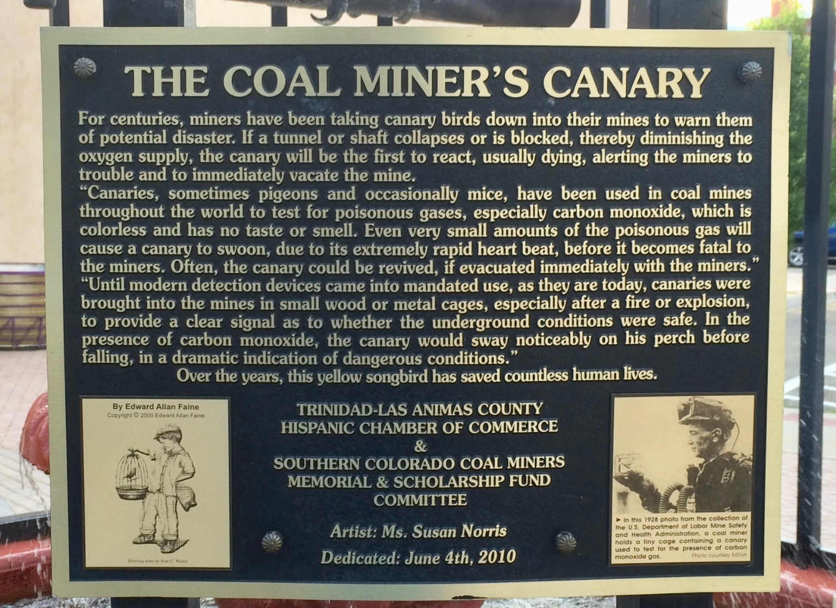

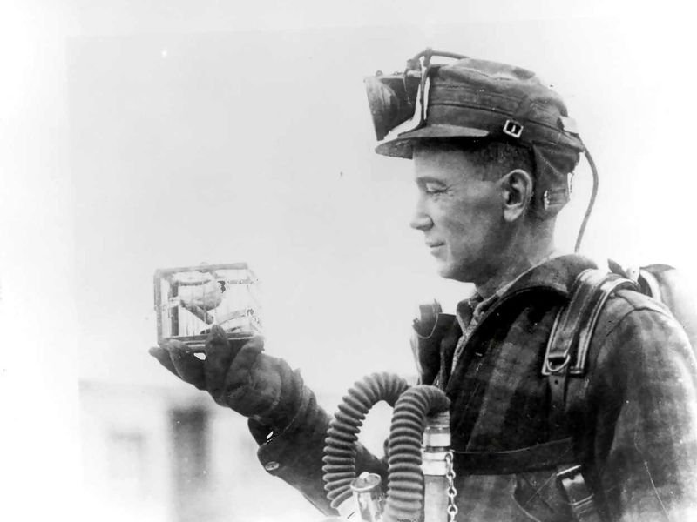

**Find the Carbon Monoxide Alarms in Your Home**

1. Ask your parents to help you find the **carbon monoxide (CO) alarms**

and the **smoke alarms** in your home.

1. Draw a picture of your home in the space below.
2. On your drawing, mark an ‘O’ in the rooms where you found CO alarms.

Mark an ‘X’ in the rooms where you found smoke alarms.

**__________________________________________________________________________________________________**

 